AI Blog Nest: AI-Powered Blog Generation Platform
TEAM ID: SWTID-2026-5963
TEAM LEADER:
Priyadharshini V
TEAM MEMBERS:
Priyadharshini R
Shubhasshree J
Tharani G

Project Description:
AI Blog Nest harnesses Generative AI to provide intelligent blog content generation, offering users a fast and personalized content-creation experience. The platform allows users to enter a topic or content idea and generate structured blog content using Gemini AI. The generated content can be reviewed, edited, and stored for future reference.
AI Blog Nest uses Gemini AI Studio for AI-powered content generation and MongoDB for storing blog information. MongoDB Atlas provides a secure cloud-hosted database environment, while the backend exposes APIs that are developed and tested using Thunder Client in Visual Studio Code.
The application is designed to simplify the blog-writing process by combining AI generation, database storage, and API-based application development in a single platform.

Scenarios
Scenario 1: A user enters a topic such as “Artificial Intelligence in Education” and requests a blog. AI Blog Nest sends the topic and relevant instructions to Gemini AI and receives a structured blog containing a title, introduction, body sections, and conclusion.
Scenario 2: A user wants to create a technology article about a new software trend. The user provides the topic and preferred content details. The system generates suitable blog content which can then be saved in MongoDB for later use.
Scenario 3: A user wants to access previously generated blogs. The application retrieves the stored blog documents from MongoDB Atlas through the backend API and displays them to the user.

Technical Architecture:
Description: AI Blog Nest utilises a modular application architecture in which the frontend provides the user interface, the backend manages API requests and application logic, Gemini AI handles blog content generation, and MongoDB stores the generated blog data. MongoDB Atlas provides the cloud database infrastructure. Thunder Client in Visual Studio Code is used to send requests to the backend APIs and verify their responses.
The typical request flow is: User Interface → Backend API → Gemini AI / MongoDB → Backend API → User Interface. Blog-generation requests are processed through the Gemini AI integration, while save, retrieve, update, and delete operations interact with MongoDB Atlas.
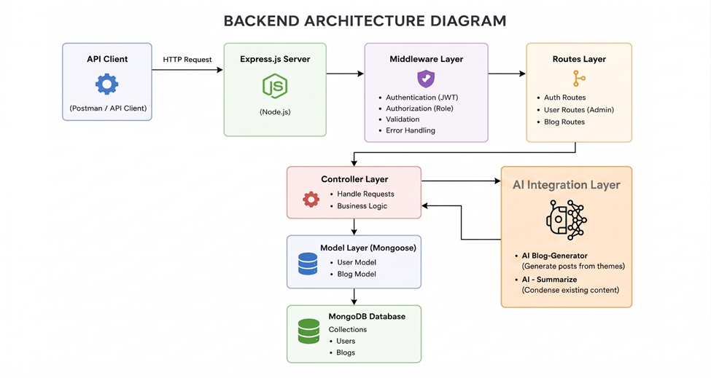

ER Diagram / Database Design
AI Blog Nest uses MongoDB, which stores data as collections of JSON-like documents rather than traditional relational tables. The main blog document can contain fields such as title, topic, content, author information, creation date, update date, and other metadata. If authentication is implemented, a Users collection can be associated with the Blogs collection through a user identifier.
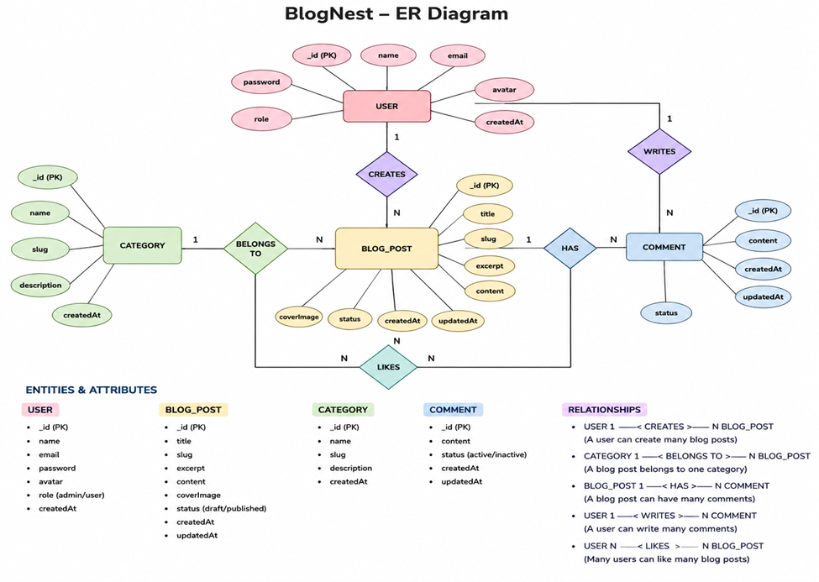
Database Description: The Blogs collection stores generated blog records. Each document may contain a unique identifier, blog title, topic, generated content, author/user identifier, timestamps, and optional category or tags. MongoDB Atlas hosts these collections in the cloud and allows the application backend to access them through a secure connection string.

Pre-requisites:
- MongoDB Knowledge: Understanding of MongoDB databases, collections, and documents.
- MongoDB Atlas Familiarity: Knowledge of creating an Atlas cluster, database, collection, and connection string.
- Gemini AI Studio Familiarity: Understanding of Gemini API access and prompt-based content generation.
- Node.js and Backend Programming Proficiency: Knowledge of Node.js and the backend framework used in the project.
- HTML, CSS, and JavaScript Skills: Required for developing the user interface.
- REST API Knowledge: Understanding of GET, POST, PUT/PATCH, and DELETE requests.
- Thunder Client Familiarity: Ability to create and test API requests inside Visual Studio Code.
- Version Control with Git: Basic Git and GitHub knowledge.
- Development Environment Setup: Visual Studio Code, Node.js, npm, and required project dependencies.

Project Workflow:

Milestone 1: Model Selection and Architecture
- Activity 1.1: Create/configure access to Gemini AI Studio and obtain the required API credentials.
- Activity 1.2: Research the available Gemini capabilities and select the model suitable for blog generation.
- Activity 1.3: Define the application architecture, including the frontend, backend, Gemini AI integration, MongoDB, and MongoDB Atlas.
- Activity 1.4: Set up the development environment in Visual Studio Code and install the required dependencies.

Milestone 2: MongoDB Atlas Setup and Database Development
- Activity 2.1: Create a MongoDB Atlas account and create a database deployment/cluster.
- Activity 2.2: Configure database access, network access, and database users.
- Activity 2.3: Create the AI Blog Nest database and Blogs collection.
- Activity 2.4: Configure the MongoDB connection string securely using environment variables.
- Activity 2.5: Define the document structure for storing generated blogs.

Milestone 3: Core Functionalities Development
- Activity 3.1: Develop the blog generation functionality using Gemini AI.
- Activity 3.2: Develop API endpoints for creating and storing blogs.
- Activity 3.3: Develop API endpoints for retrieving saved blogs.
- Activity 3.4: Implement update and delete operations where required.
- Activity 3.5: Add input validation and error handling.

Milestone 4: App.js / Main Backend Development
- Activity 4.1: Create the main backend application file and configure the server.
- Activity 4.2: Configure middleware for JSON requests and application-level processing.
- Activity 4.3: Connect the backend to MongoDB Atlas.
- Activity 4.4: Configure routes for blog generation and database operations.
- Activity 4.5: Integrate the Gemini AI API into the backend.

Milestone 5: API Testing Using Thunder Client
- Activity 5.1: Create Thunder Client requests for all backend endpoints.
- Activity 5.2: Test POST requests for generating and saving blog content.
- Activity 5.3: Test GET requests for retrieving blog records.
- Activity 5.4: Verify HTTP status codes, response structure, validation, and error handling.

Milestone 6: Deployment
- Activity 6.1: Prepare the application for local deployment.

Milestone 7: Conclusion
The final milestone focuses on evaluating the completed AI Blog Nest application, confirming that the AI generation, database storage, retrieval, and API testing workflows operate correctly.

Milestone 1: Model Selection and Architecture
In this milestone, we focus on selecting and configuring the Gemini AI service for AI-powered blog generation. The application architecture is defined so that the frontend communicates with the backend, the backend communicates with Gemini AI for generation, and MongoDB Atlas stores the resulting blog documents.

Activity 1.1: Generate a Gemini AI Studio API Key
- Create or sign in to the required Google/Gemini AI Studio account.
- Open the API key section in Gemini AI Studio.
- Create an API key for the application.
- Copy the generated API key and store it securely.
- Create a .env file in the root directory of the project.
- Add the Gemini API key as an environment variable.
- Add .env to .gitignore so that the key is not committed to a public repository.
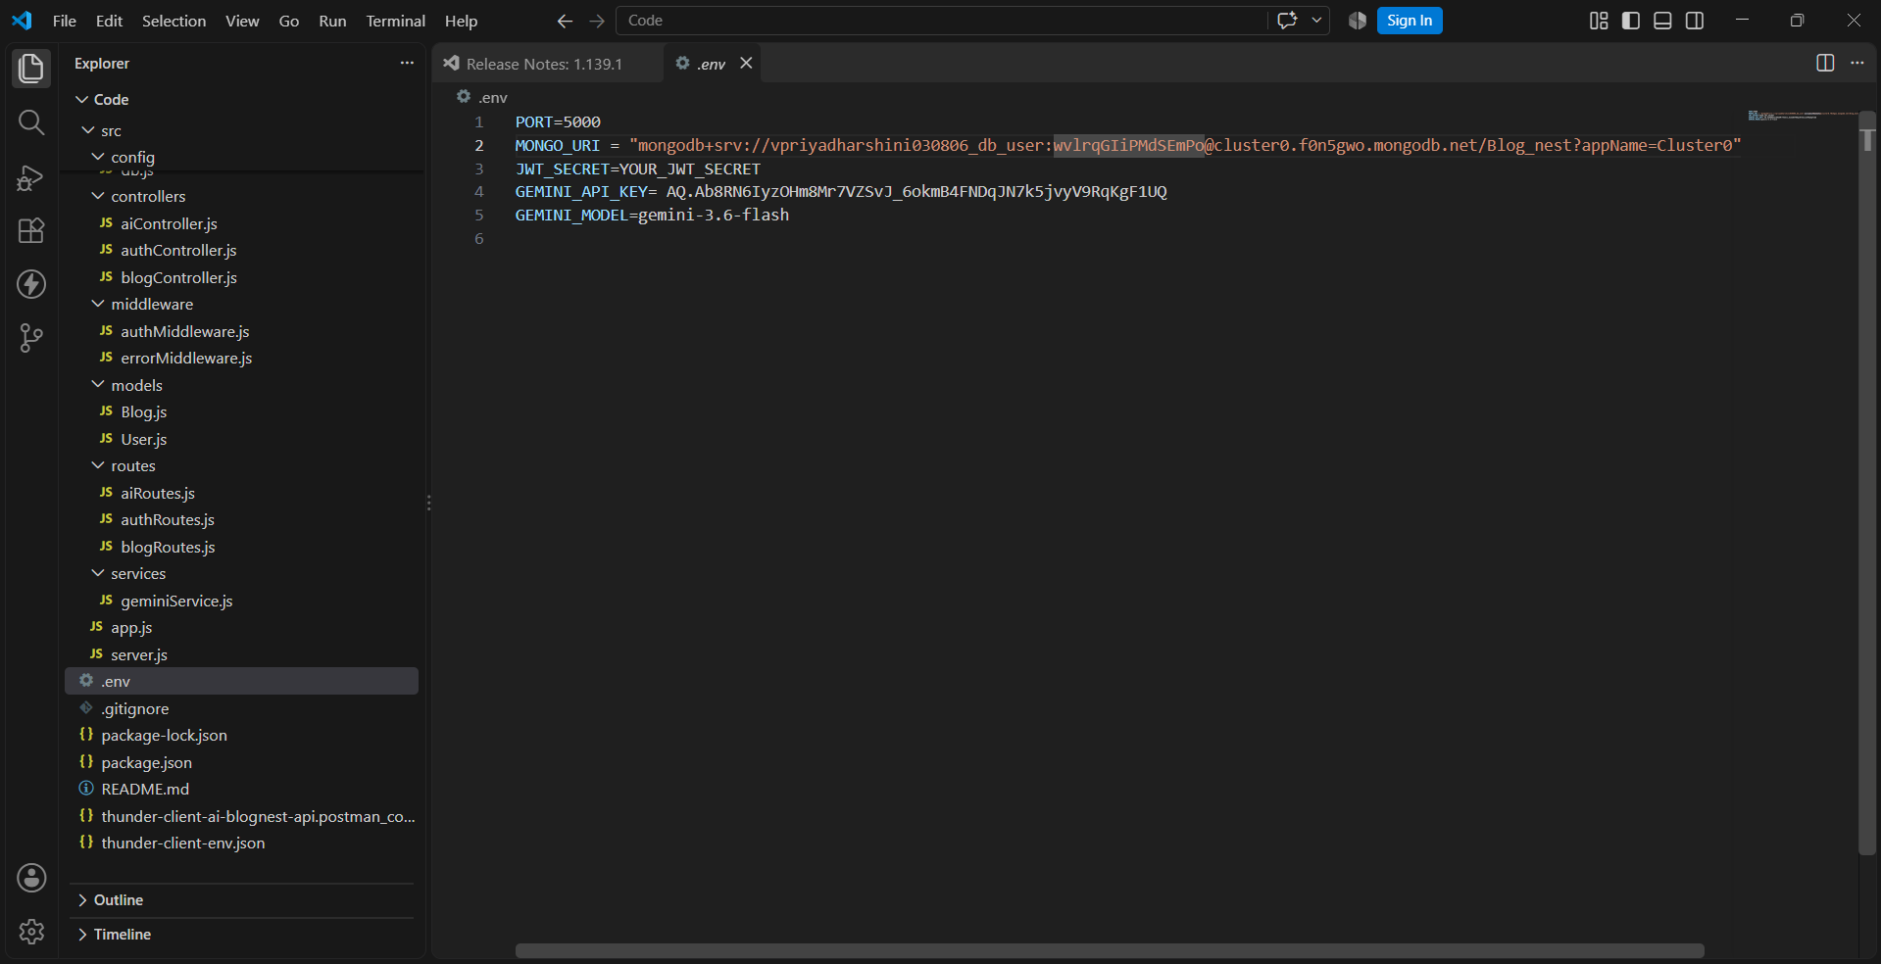

Activity 1.2: Research and Select the Appropriate Generative AI Model
- Understand the project requirements: The application needs coherent, structured, and relevant blog content.
- Explore Gemini documentation and available model capabilities.
- Evaluate response quality, context handling, speed, and output consistency.
- Select the Gemini model supported by the project configuration and suitable for blog generation.
- Define prompt instructions for title, introduction, sections, body content, and conclusion.

Activity 1.3: Define the Architecture of the Application
- Draft an architectural diagram representing the frontend, backend, Gemini AI, MongoDB, and MongoDB Atlas.
- Define how users submit a topic or blog request.
- Define how the backend validates the input and constructs a Gemini prompt.
- Define how Gemini returns the generated content to the backend.
- Define how the backend stores the generated blog in MongoDB Atlas.
- Define how saved blogs are retrieved and displayed to users.
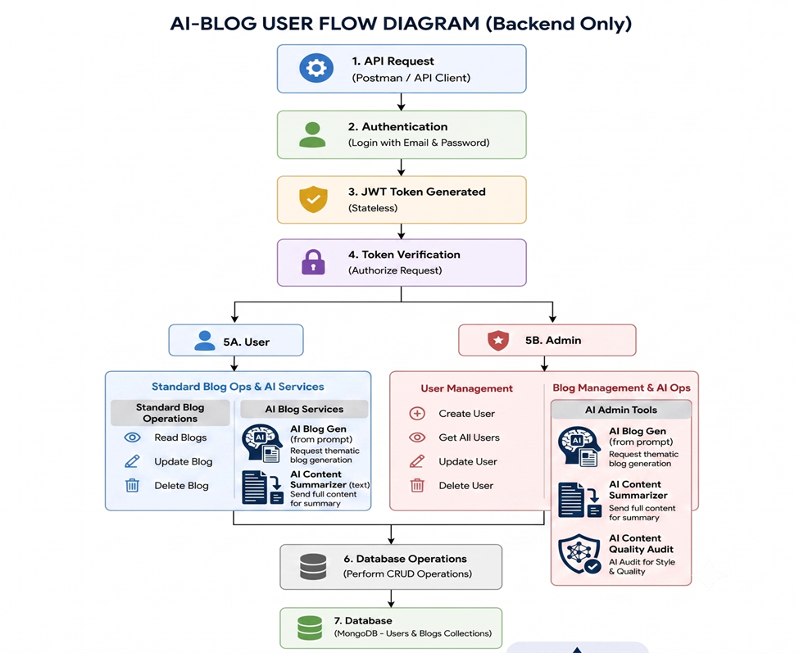

Activity 1.4: Set Up the Development Environment
Install the required software and libraries for the project. Open the AI Blog Nest project in Visual Studio Code and initialize the backend environment.
- Install Node.js and npm.
- Create/open the project folder in Visual Studio Code.
- Initialize the project using npm where required.
- Install the backend framework and required MongoDB and Gemini SDK/client packages.
- Install dotenv support for environment variables.
- Install and configure any frontend dependencies used by the project.
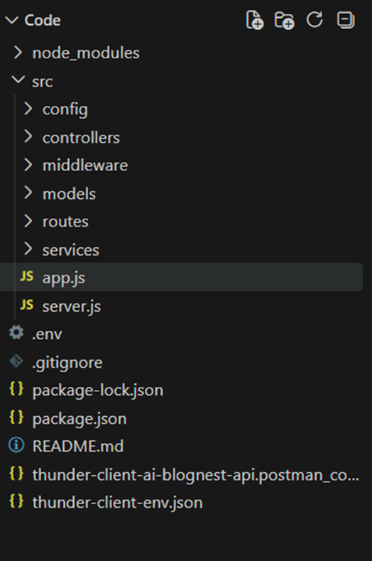

Milestone 2: MongoDB Atlas Setup and Database Development
This milestone focuses on creating the cloud database environment required by AI Blog Nest. MongoDB Atlas is configured as the database hosting platform, while MongoDB collections and documents are used to store generated blog information.

Activity 2.1: Create a MongoDB Atlas Deployment
- Create or sign in to MongoDB Atlas.
- Create a new project for AI Blog Nest.
- Create the required database deployment/cluster.
- Configure the database user and password.
- Configure network access according to the development requirements.
- Obtain the MongoDB connection string.
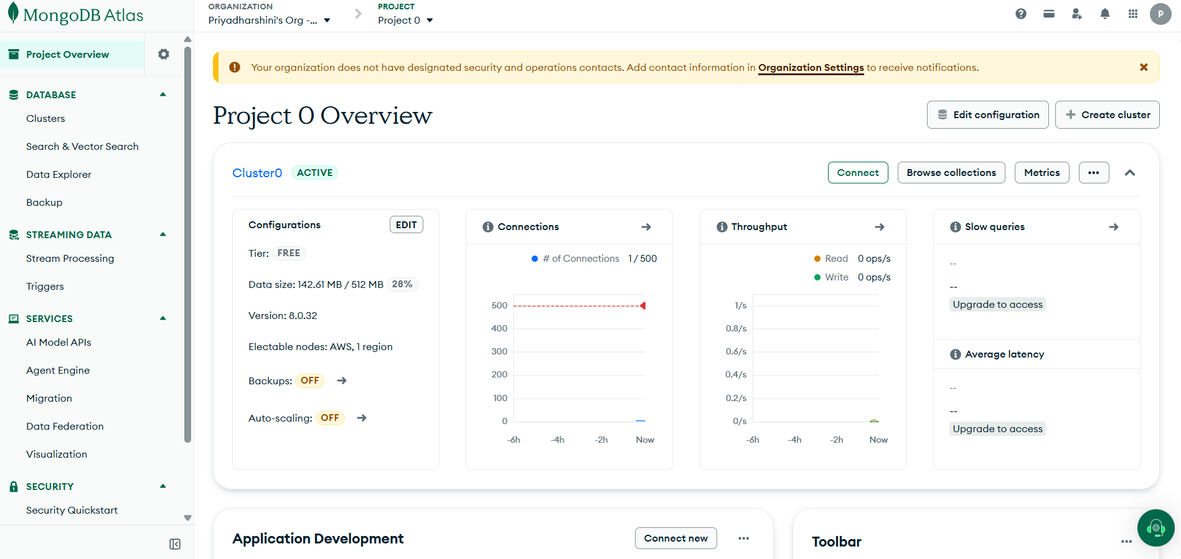

Activity 2.2: Create the Database and Collection
- Create the AI Blog Nest database.
- Create the Blogs collection.
- Define the fields required for each blog document.
- Insert sample documents to verify database connectivity.
- Verify that documents can be viewed and managed through MongoDB Atlas.

Activity 2.3: Configure the MongoDB Connection
Store the MongoDB Atlas connection string in the .env file rather than hard-coding credentials inside application source files.
Example environment variables:
MONGODB_URI=your_mongodb_atlas_connection_string
GEMINI_API_KEY=your_gemini_api_key

Milestone 3: Core Functionalities Development
Implement the main AI Blog Nest functions: accepting a topic, generating blog content with Gemini AI, storing generated content in MongoDB, retrieving saved blogs, and managing blog records.

Activity 3.1: Develop the Blog Generator
- Accept a blog topic or content idea from the user.
- Validate that the topic is not empty.
- Construct a structured prompt for Gemini AI.
- Send the request to Gemini AI through the backend.
- Receive the generated blog content.
- Return the result to the frontend in a structured API response.
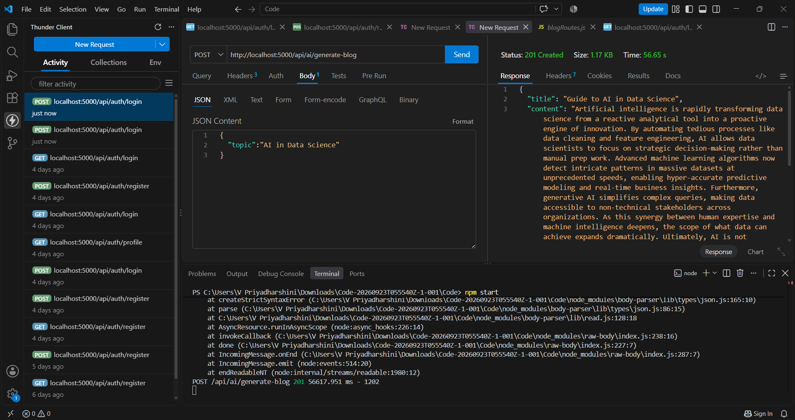

Activity 3.2: Store Generated Blogs in MongoDB
- Create a blog document after successful AI generation.
- Store the title, topic, generated content, and relevant metadata.
- Store creation and update timestamps where implemented.
- Insert the document into the Blogs collection.
- Return the stored document or its identifier through the API.

Activity 3.3: Retrieve Saved Blogs
- Create a GET API endpoint for retrieving blogs.
- Query the Blogs collection.
- Return blog documents in JSON format.
- Display the retrieved blogs in the frontend.

Milestone 4: App.js Development
Milestone 4 focuses on creating and refining the main backend logic of AI Blog Nest. The backend serves as the connection between the frontend, Gemini AI service, and MongoDB Atlas database.

Activity 4.1: Writing the Main Application Logic in App.js
- Configure the backend server.
- Load environment variables using dotenv.
- Initialize the MongoDB connection.
- Initialize the Gemini AI client/configuration.
- Configure the required API routes.
- Add validation and error handling.

Define the Core Routes in App.js:
- / — Home page or application entry point.
- /api/blog-generate — POST endpoint for AI blog generation.
- /api/blogs — GET endpoint for retrieving saved blogs.
- /api/blogs — POST endpoint for saving blog content where implemented.
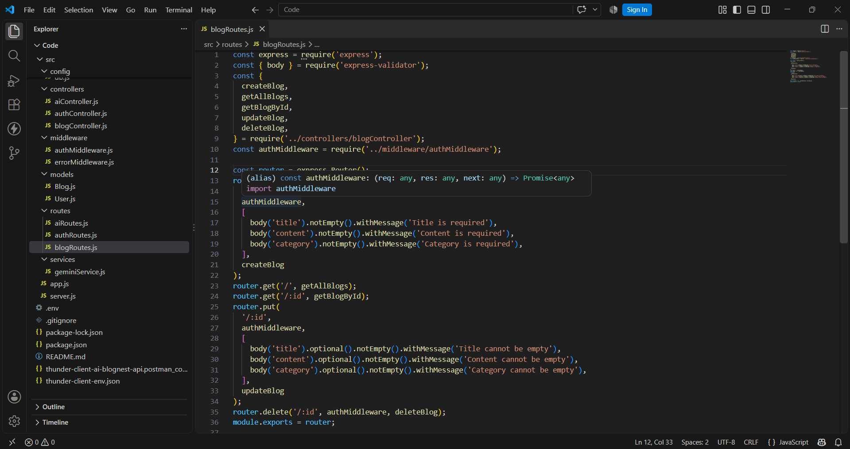

Define Prompt Engineering Helpers:
- Define the system/application instruction for the Gemini model.
- Create a structured user prompt containing the requested topic.
- Specify the desired blog format, including title, introduction, headings, body, and conclusion.
- Specify the desired writing tone and approximate level of detail.
- Request a consistent response structure to simplify frontend rendering and database storage.

Integrate the Gemini AI Responses in Each Function:
- Send the structured prompt to Gemini AI.
- Receive the generated response from the model.
- Validate the response before returning it to the frontend.
- Handle API failures and invalid responses gracefully.
- Store the final generated blog in MongoDB when the user chooses to save it.

Milestone 5: API Testing Using Thunder Client
Thunder Client is used inside Visual Studio Code to test the REST APIs of AI Blog Nest. Each endpoint is tested with appropriate request methods, headers, request bodies, and expected responses.

Activity 5.1: Create Thunder Client Requests
- Open Thunder Client from the Visual Studio Code sidebar.
- Create a collection named AI Blog Nest API.
- Create requests for the available blog-generation and database endpoints.
- Configure the required HTTP method, URL, headers, and JSON body.
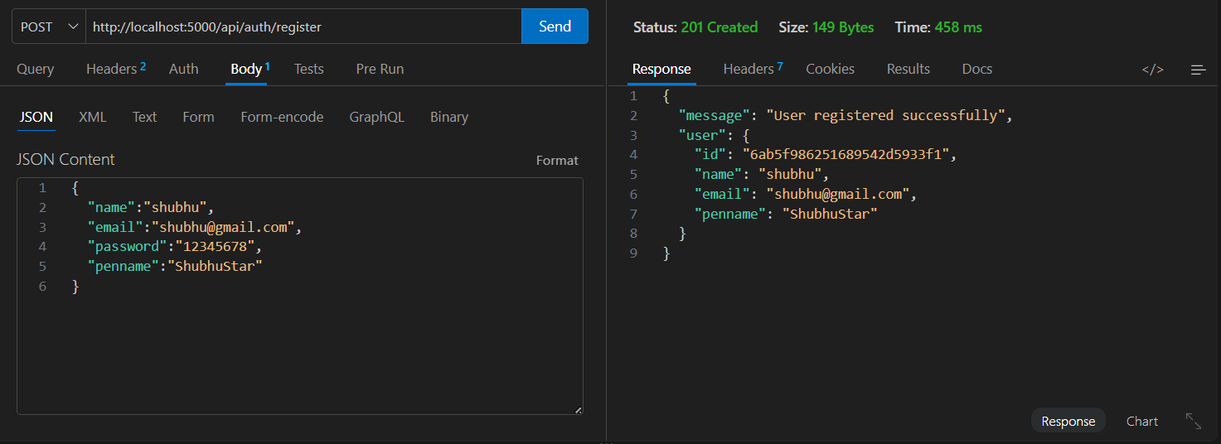

Activity 5.2: Test the Blog Generation API
Example request structure:
POST /api/blog/generate
{
"topic": "AI in Data Science”
}
The expected response should contain the generated blog information or an appropriate error message when the request is invalid.
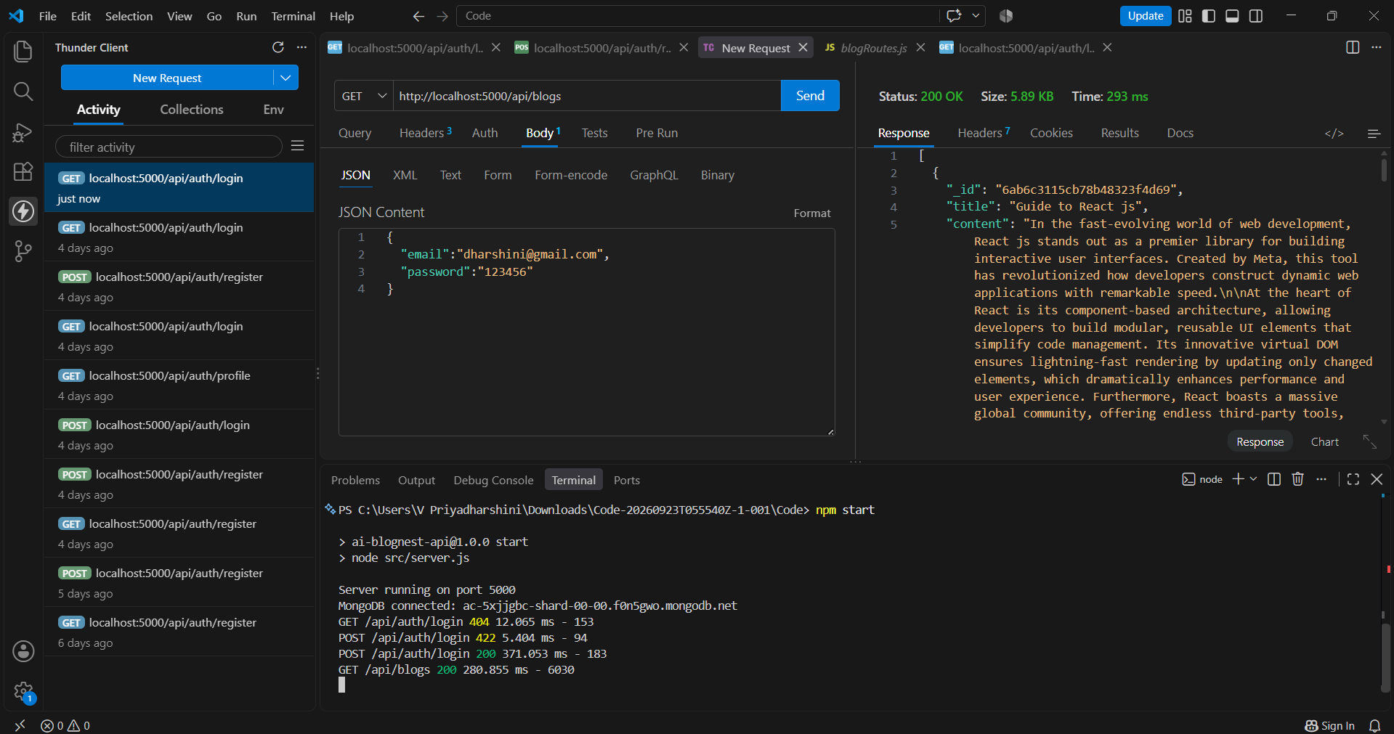

Activity 5.3: Test MongoDB CRUD APIs
- GET: Retrieve saved blog documents.
- POST: Save a generated blog document.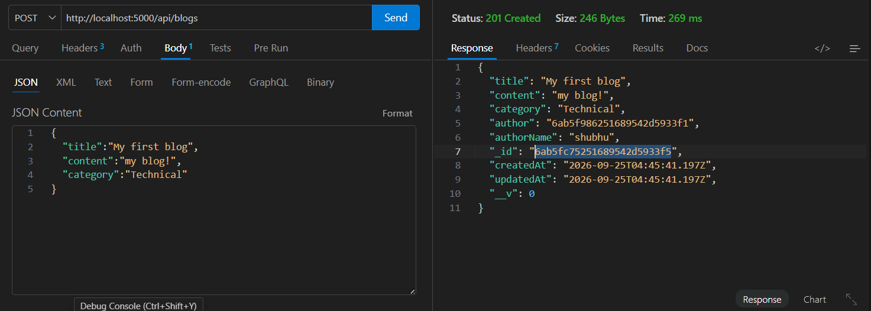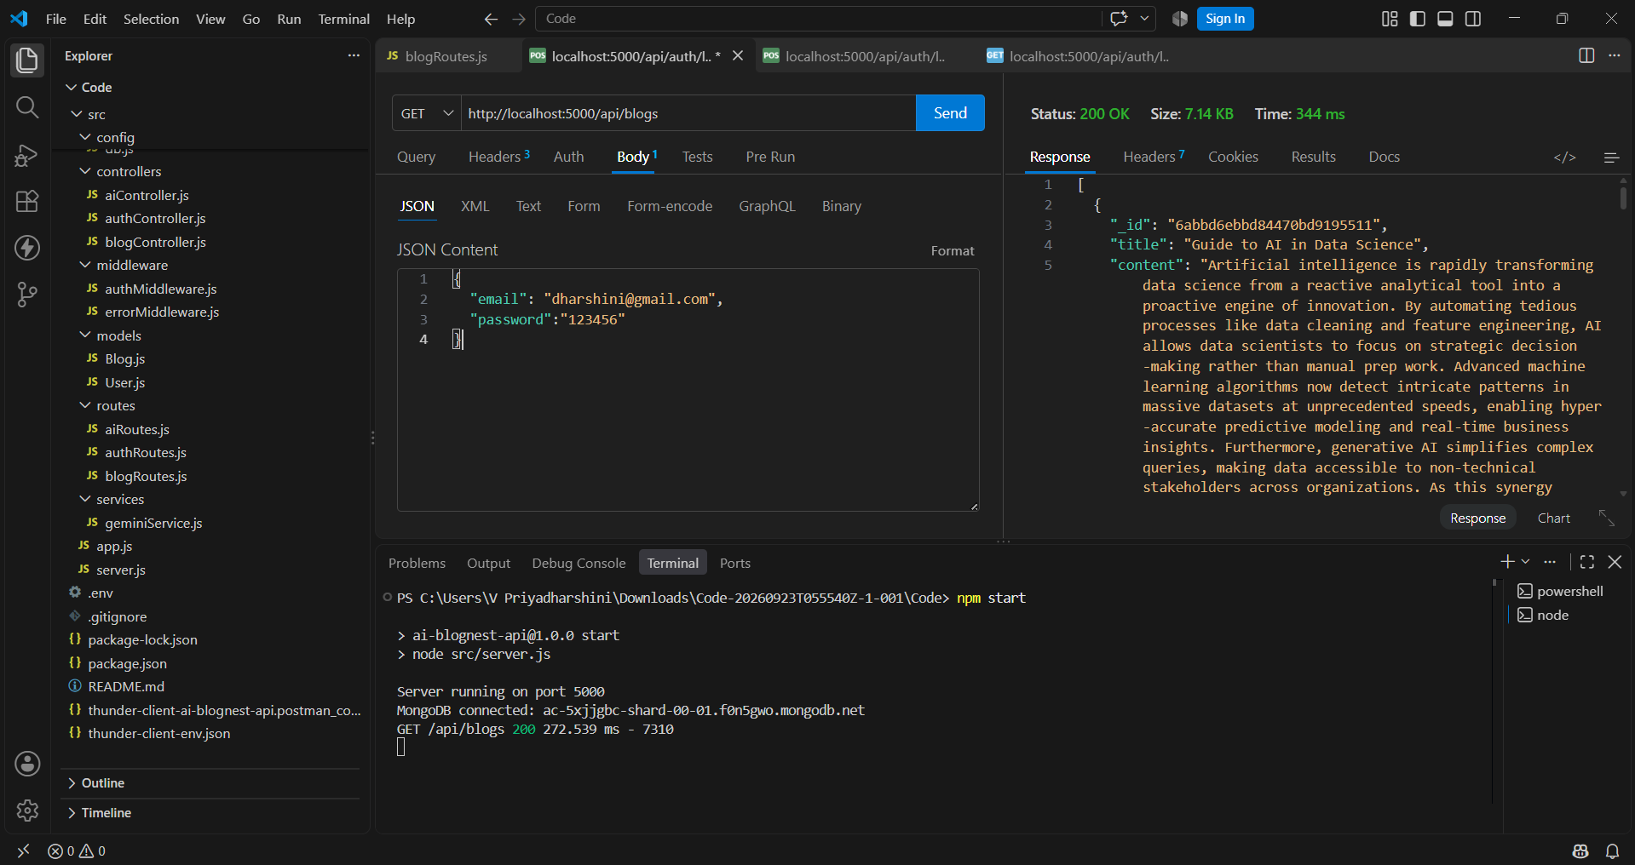

Activity 5.4: Validate Responses and Error Handling
- Verify successful HTTP status codes.
- Verify JSON response structure.
- Test empty or invalid input.
- Test database connection errors.
- Test Gemini API errors.
- Verify that meaningful error messages are returned to the client.

Milestone 6: Deployment
In Milestone 6, the application is prepared for deployment after local testing. MongoDB Atlas continues to provide the cloud database, while the deployed backend uses securely configured environment variables for Gemini AI and MongoDB credentials.

Activity 6.1: Preparing the Application for Deployment
- Verify that all dependencies are listed in package.json.
- Verify that environment variables are not hard-coded.
- Confirm MongoDB Atlas network access and database credentials.
- Test all API routes locally.
- Confirm that the frontend communicates correctly with the deployed backend configuration.
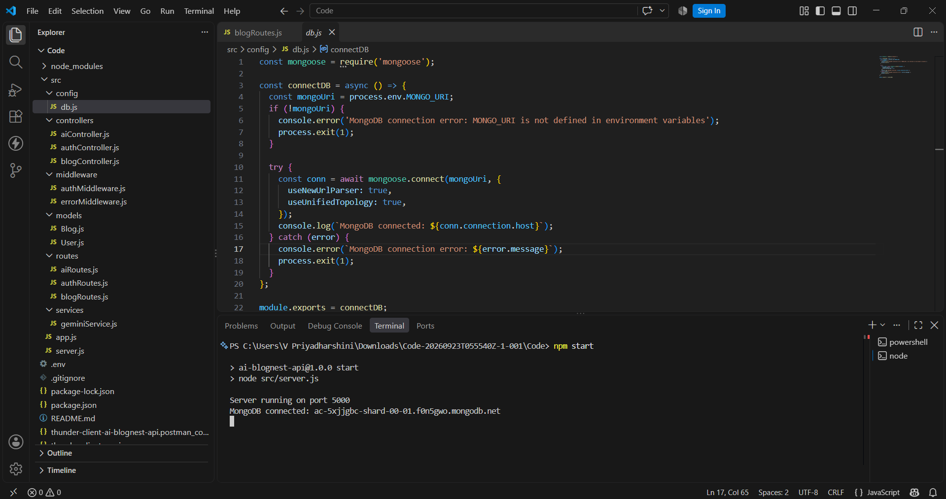

Conclusion:
AI Blog Nest is an AI-powered blog generation platform that combines Generative AI with cloud database technology to streamline content creation. The application uses Gemini AI Studio for generating structured blog content and MongoDB for storing the generated information.
MongoDB Atlas provides the cloud database environment, allowing the application to store and retrieve blog documents through backend APIs. Thunder Client in Visual Studio Code provides a convenient environment for testing the application's REST APIs and verifying request and response behaviour.
The project demonstrates the integration of AI services, REST APIs, cloud database management, frontend development, backend programming, and API testing into a single application. The modular architecture also provides opportunities for future enhancements such as user authentication, blog categorisation, multilingual generation, AI-assisted editing, search, favourites, analytics, and improved content management.
Demo Video :Demo Video.mp4
API Testing :API Testing Video.mp4
CodeDrive: AI BlogNest Code
GitHub Repository: https://github.com/VPriyadharshini386/AI_Blognest.git

